Cooperation Opportunities between Hin Nam No National Park and
Phong Nha-Ke Bang National Park as transboundary World Heritage site

Background of the Transboundary Cooperation between Phong Nha-Ke Bang World Heritage Site and Hin Nam No National Park
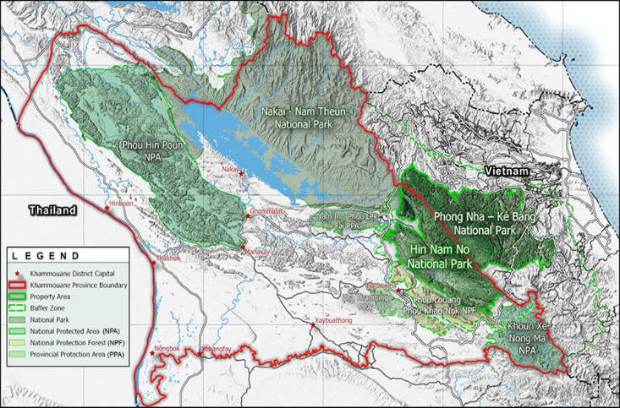
Hin Nam No National Park (HNN NP) and Phong Nha-Ke Bang National Park (PNKB NP) in Vietnam are situated next to each other in the heart of the Annamite Mountains. The Greater Annamite landscape harbors relatively intact moist forests with 75 protected areas (PA) with high biodiversity. The landscape has high conservation value. The current representation of the outstanding biodiversity values on the World Heritage List is restricted only to Phong Nha - Ke Bang National Park. PNKB NP was first inscribed on the World Heritage List in 2003. Following a major extension in 2015, the Vietnamese property now exceeds 123,000 ha. Since that time, the 3 respective WH CoP meetings in 1999, 2003 and 2015 included resolutions as official request to the Vietnam S.R. to continue support and encouragement for Lao PDR to nominate the Hin Nam No to be the “Transboundary Extension of the PN-KB WH” of Vietnam. On 15th July 2016 the Government of Lao PDR (GoL) has submitted its intention to propose the HNN NP in the Tentative List of natural World Heritage Sites to UNESCO. Following years of constructive dialogue and explicit encouragement by the World Heritage Committee, in February 2023, the GoL submitted the nomination of Hin Nam No National Park as Transboundary Extension to Phong Nha-Ke Bang World Heritage Site of Vietnam to UNESCO. If approved, this extension will add 94,000 ha to the PNKB site, resulting in almost 220,000 ha of intact and fully conserved land. Furthermore, it will ensure that the full biological and cultural diversity of the landscape is represented under the World Heritage listing and will significantly increase the ecological integrity of PNKB. The recognition of this extension would lead to the creation of the first transboundary World Heritage property of Southeast Asia and possibly constitute the largest karst reserve in the world.
Figure 1 Transboundary property in the landscape protected area of Khammouan province, Lao PDR. Map at scale 1:1’100’000 (Nomination Dossier 2023)

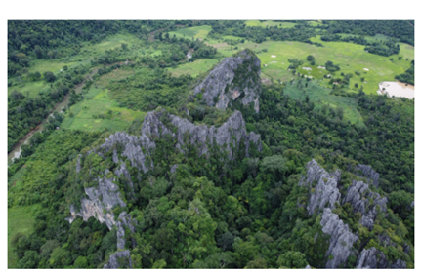
Significance and Outstanding Universal Value (OUV) of the transboundary site
The karst formation has evolved since the Palaeozoic period approximately 400 million years ago and can be considered the oldest large-scale karst area, vastly diverse and undisturbed area in Asia. The karst formation process has also led to the creation of extensive enclosed depressions and an extraordinary variety of cave types including dry caves, terraced caves, suspended caves, dendritic caves, and intersecting caves. The two most prominent caves are the Son Doong Cave in Phong Nha-Ke Bang NP, and the Xe Bang Fai Cave in Hin Nam No NP. The former cave contains the world’s largest known cave passage in terms of diameter and continuity, while the latter cave plausibly presents the world’s most productive karst spring peaking in the rainy season with a discharge reaching an estimated 2,880 cubic meters per second.
Figure 2: Landscape of Hin Nam No National Park, Lao PDR (Photo: GIZ ProFEB)
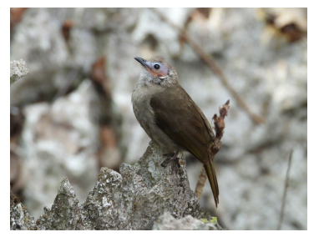
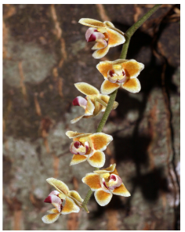
The transboundary property represents the most significant and essentially intact karst ecosystem component within the Annamite Range Moist Forests. Among the diverse ecosystems and habitats across the transboundary property, the dry karst mountain tops with their highly specialized and often endemic flora and fauna stand out. The same holds true for the lush semi-deciduous and evergreen forests in the valleys between the karst mountains in both parks, the undisturbed and remote high-altitude forest on sandstone in HNN NP and the rare Calocedrus rupestris conifer forest on limestone in PNKB NP. The transboundary property is renowned for its high degree of floral and faunal endemism, especially orchids, begonia species and bent toed geckos. Below ground, the cave systems and subterranean watercourses have permitted the ongoing evolution of extremely specialized organisms.
Figure 3: Tiny orchid Chiloschista pulchella in Hin Nam No National
Park, Lao PDR (Photo: Leonid V. Averyanov)
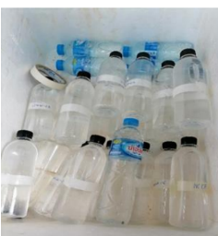
Surveys of the vast and mostly pristine forest habitats routinely reveal species unknown to science, found out key species richness of the transboundary complex by far exceeds the individual richness of PNKB NP and HNN NP, respectively. It is assumed that of over 400 plant species in the transboundary complex are endemic to Central Lao PDR and/or Vietnam, 38 animal species are even endemic to the Annamite Range. There is also a high number of terrestrial and aquatic karst specialist species. Depending on the application of evolving taxonomic frameworks, there are 10, 11 or even primate species within the property, four endemic to the Annamites. These include the largest remaining population of the critically endangered Southern white-cheeked Gibbon (Nomascus siki) and the endemic Black Langur (Trachypithecus ebenus).
Figure 4 Bare-faced Bulbul (Nok hualon) in its typical habitat in Hin Nam No National Park, Lao PDR
(Photo: Nguyen Dinh Duy)
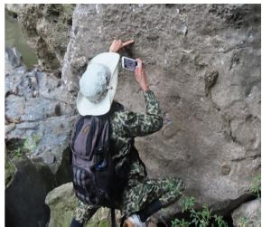
In addition, in 2022, Hin Nam No National Park management team also cooperated with the Vietnam academy of science and technology institutes of geological science to carry out a geological survey, biodiversity and survey water in Hin Nam No National Park and 10 nearby villages, which could collect a total of 99 samples of water, rocks, and soil and explore 37 species of biodiversity.
Protection and management of the transboundary site
Originally designated as a Nature Reserve in 1986, Phong Nha-Ke Bang National Park was established in 2001 under the Decision 189/QD-TTg by the Prime Minister and is managed by a Management Board. The National Park is effectively protected by a number of national laws and government decisions and a Strategic Management Plan has been in place since 2012. The Management Board oversees law enforcement programmes including ranger patrols and joint law enforcement operations on the border with Lao PDR.
HNN NP in was designated a national protected area in 1993 and was subsequently managed as a conservation forest under the then Laotian Forest Law. In 2000 HNN was decreed as a national park under the new Forest Law of 2019, which mainstreams contemporary international standards and best practices for nature conservation in Laos and listed as green list-site in 2021. Consecutive management plans are the foundation for the management of HNN NP, along with land use plans for the buffer zone and specific tourism management and development plans and regulations. Since 2016 management planning builds on a collaborative system, including a district level collaborative management committee of 14 representatives, and 19 village committees. Partners encompass almost 100 trained community forest rangers and village tourism service groups and district-level partner agencies. A National Park Directorate headquartered in Boualapha will report directly to the Protected Area Management Division under the Ministry of Agriculture and Forestry. Established in 2021, a Provincial Steering Committee for HNN NP is to oversee implementation of the 5-year Management Plan for HNN NP, the transboundary management activities between HNN NP and PNKB and Community Resolutions stemming from the consultations surrounding free, prior and informed consent (FPIC) for the World Heritage nomination. The collaborative management is to ensure the effectiveness of protection and management, including on the border with Vietnam, while also promoting local stewardship and engagement at district and village levels.
Both sites were registered in the Green List and since 2021 undergo the process of the preparation of a Green List Gap Analysis. The draft report of the Green List Gap Analysis for both were consulted with various levels. Both national parks see the Green List Gap Analysis process as critical for the assessment of protected areas effectiveness in terms of governance, sound planning, management of the park, monitoring and measurement of success.
Recent developments in transboundary cooperation
A lot of progress has been made in recent years to increase the cross-border cooperation towards the transboundary extension, particularly on paper, expressing good will intentions at higher levels of the government. This includes the setup of a transboundary technical provincial level working group for the nomination in 2020, an agreement on an annual cooperation plan signed by both prime ministers in 2020, the development of a HNN-PNKB transboundary management framework (TBMF) in 2021, the setup of focal points for the nomination in both countries and defining the mandate of the provincial steering committee meeting for Hin Nam No in such a way that it includes transboundary coordination on the ground for nomination and implementation of transboundary management work.
The shared World Heritage designation is a platform and incentive to further work towards ever more effective communication, coordination and cooperation across the border crossing a transboundary ecosystem. Based on an agreed conceptual framework and model for the transboundary cooperation between PNKB and HNN and as proposed in the state of conservation report of PNKB to UNESCO of 2020, the two parks and its provincial steering bodies signed a Memorandum of Understanding on collaboration between HNN and PNKB in 2023. The MoU outlines working areas and agreed modalities for transboundary management and steering and commits the two parks to the development and implementation of a transboundary action plan.
Areas for further intensifying cross-border cooperation
- Poaching is by the far the greatest threat to HNN and PN-KB’s globally threatened wildlife and consequently to the OUV of the transboundary WHS. The main driver is commercial trade not food security. As a result, every month, tens of thousands of snares are removed and tens of thousands more re-laid. Both sites see the important of the protection natural resources through the collaboration between the two sites, including preparation of legal documents on co-management and supporting system for data base and information exchange. Until recently, logging was also a major threat to PN-KB’s OUV. However, the agreement of a FLEGT Voluntary Partnership Agreement (VPA) between Vietnam and the EU in 2019 and the fact that PN-KB has been “logged out” of its high value tree species have substantially reduced logging inside the WHS. Nevertheless, it remains a localized threat in both parks. It is recommended to use a new approach tested by the USAID BCA which targets professional poachers with a combination of incentives (alternative income opportunities tailored to need) and disincentives (improved case tracking to dramatically increase the probability of arrest and prosecution, etc.). In addition, both parks adopt SMART patrol systems to document patrol coverage, detections, violations, etc. This will simplify and facilitate data sharing. SMART patrols should be supported by informal monthly meetings of senior anti-poaching staff from the two parks to discuss anti-poaching strategies. Thus, there is a need to set up a shared center or network to share and exchange database and information regularly.
- Biodiversity research in HNN NP and PN-KB NPs is critically important to set research priorities, define research methodologies, provide on-the-job training and skills development towards a long-term research program on the OUV of both sites and on factors affecting the OUV, in particular to some taxa (e.g. primates), hydrogeology, and climate dynamics. It is recommended that the two parks research specialists should have a joint research group in the form of collaboration on karst, cave, and biodiversity as this is highly to continue to take advantage building its human resource capacities. Due to the importance of biodiversity protection, there is a need to focus on data improvement for future sustainable conservation.
- While there is a growing body of research of the OUVs of both sites, there is very little information about their cultural values, despite the fact the two sites are home to about eight ethnic minorities with distinct languages, traditions, and practices. Interpretation materials for PN-KB NP may give the impression that the site is uninhabited, which is not the case. However Ethnic minority communities in both parks depend on forest resources for their livelihoods. By having set up the effective natural resources management and framework to improve the local livelihood and mitigation of the trade and poaching of the two parks in order to protect the abundance of the ecosystem in the parks. It is recommended that both management boards negotiate agreements with these communities that ensure sustainable use of these resources.
- Both HNN and PN-KB NP have been faced with the plans of infrastructure development, extractive industries like railways, roads, and others that will threaten the OUV, the status of the entire transboundary WH site will be at risk. Infrastructure planning that prioritizes the OUV is therefore a joint responsibility, including informed of any investments in the areas and provisions for EIAs on any investments (roads, cable cars, etc.) that could threaten the OUV, common investment and development plans and provisions for emergency situations (forest fires, floods, accidents, etc.).
- Tourism is a growing industry, especially for PN-KB NP compared to HNN NP. However, both sites will see this as main income opportunity for the management of the sites. It is recommended that PN-KB and HNN cooperate on joint tourism planning process or a Sustainable Tourism Workshop Group (tourism management) as well as a joint marketing and presentation of the area.
In summary, all five thematic areas are highlighted above, however there is further collaboration needed on transboundary communications (including joint monitoring, reporting, information sharing, research strategy), law enforcement for illegal transboundary activities, provisions for EIAs on any investments (roads, cable cars, etc.) In summary, all five thematic areas are highlighted above are critical important, however there is further collaboration needed on transboundary communications (including joint monitoring, reporting, information sharing, research strategy), law enforcement for illegal transboundary activities, provisions for EIAs on any investments (roads, cable cars, etc.) that could threaten the OUV, common investment and development plan and provisions for emergency situations (forest fires, floods, accidents, etc.). For now, there are high difference between the technical capacities in the management of the two parks. On the one hand the well-advanced WH expertise at PN-KB NP and on the other hand HNN NP which is recently in the initial stage of WH nomination and is therefore supported by GIZ and Worldbank in terms of institutional arrangements and human resources. Therefore, the exchange on lessons learnt and mutual technical support are critical.

Ways forward towards the success of the transboundary cooperation
Both PN-KB and HNN have recently established their own committees to liaise and work together, therefore in the future there is a need to establish the “Transboundary Steering Committee” with tasks to approve annual workplans and budgets and address the threats to the two sites that are beyond the control of the management boards. Other tasks might be: monitor the conservation status of the property (monitoring reports), review proposed development/infrastructure projects including HIAs where relevant – not necessarily to have statutory approval to approve or block projects since this is the sovereign right of each government, but to at least be informed and given their advice. In addition, reviewing proposed cooperation projects by development and bilateral partners and review official reports to be transmitted to the World Heritage Centre (Periodic Reporting, State of Conservation reports) for the transboundary property.
Transboundary cooperative management depends on a shared understanding of the issues, a common vision, a set of agreed objectives and a means to deliver transboundary conservation initiatives. Wherever possible, these should be expressed through a management plan prepared and agreed jointly by both parties. Both parks are preparing new 5-year management plans based on national guidelines and are currently carrying out gap analyses based on the IUCN Green List of Protected and Conserved Areas (GL), which provides a standard framework to assess protected area management performance.
The Green List Gap Analyses can provide the basis for cooperation and the development of a transboundary management framework (TBMF) as the extensive knowledge that now exists for both HNN and PN-KB NPs can be used as specific guidance on management issues that require coordinated actions by Vietnam and Lao PDR at different levels, such as building networks and capacities by sharing experiences/best practices and finding ways as solutions. It is recommended that a comparative assessment of the GL gap analyses for both sites inform a transboundary action plan that exploits synergies and common needs to address gaps on both sides.

Resources:
- 2023. Nomination Dossier of the Nomination of Hin Nam No National Park of Lao PDR as
Transboundary Extension to Phong Nha-Ke Bang World Heritage Site in Vietnam
- 2023. Executive Summary of Hin Nam No National Park of Lao PDR as Transboundary Extension to Phong Nha-Ke Bang World Heritage site of Vietnam.
- 2022. Jake Brunner, Head, Indo-Burma Group, Him Nam No. NP/Phong Nha-Ke Bang WHS Transboundary Management Framework (draft)
- 2022. Annual Report of HNN
- 2019. Jake Brunner, Head, Indo-Burma Group, Him Nam No. NP/Phong Nha-Ke Bang WHS Transboundary Management Framework
- 2014.Hans Helmrich consultant, Nguyen Manh Ha consultant, Pham Thi Lien Hoa,GIZ “Report on consultancy work in Vietnam”

Information
Academic title : Cooperation Opportunities between Hin Nam No National Park and Phong Nha-Ke Bang National Park as transboundary World Heritage site
Author and Presenter : Mr. KHAMKEO LATTHAYOD
Position : Head director of HNN.NP
Degree : Master of Forest Science
Address : HNN office, Bualapha district khammoune province
E-mail : khamkeo.l@gmail.com
Contact phone number: +85620 5555 0245

